**Our Second Week Week in 4th Grade**

Spelling – We will begin spelling next week. There will be a list that goes home on Monday, homework most nights, and a spelling test on Friday.

Reading – We read and discussed Thank You, Mr. Falker, written and illustrated by Patricia Polacco. Next week we will begin focusing on “close reading.” Next week we will also begin our weekly reading assignment (in place of a reading log).

Writing – We will begin spending a lot of time working on writing in the coming weeks – and that includes practicing handwriting!

Social Studies – We have started our unit of Geography and will continue with that for the next few weeks.

Math – We dove into our review of place value this week, and will continue to work on this concept for a little while longer. We hope to be moving on to rounding by next week, and comparing numbers. Then off to bigger things!

Science – We are starting off the year by review and talking about the Scientific Method. I want the students to understand why and how we use the Scientific Method. After this we will be shooting for the stars as we enter out Solar and Earth lessons!

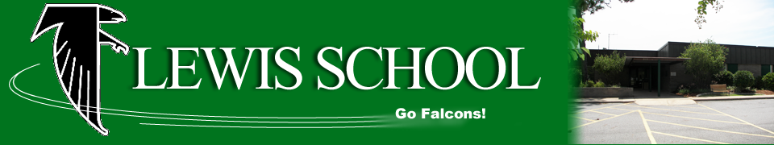

**Looking Ahead**

**Friday, Aug. 25 –** First Spelling Test

**Tuesday, Aug. 29 –** 4th Grade Parent Night @ 5:30 in the Media Center

**Monday, Sep. 4 –** Labor Day – No School!

|  |  |
| --- | --- |
| **Students of the Week** | |
| C:\Users\ChrPow61\AppData\Local\Microsoft\Windows\Temporary Internet Files\Content.IE5\KUNKM2MS\MC900356165[1].wmf  Mrs. Powers’  Tiger of the Week | **Jesse** |
| Image result for owl clip art black and white  Ms. Davis’  Owl of the Week | **Sidyna** |

***Please be sure to check our class website for updates and Homework for the week.***

lewis4thgrade.weebly.com

**4th Grade Classroom Wish List**

* Canon Printer Ink (#245 and #246)
* Colored Computer Paper