**Our Tenth Week in 4th Grade**

Spelling – This past week focused on vowel sounds /oo/ and /oo/. Next week we will study words with vowel sounds /ou/ and /o/.

Reading – Reading Reflections Logs are due Monday! Next week we will continue with our close reading, and discuss visualizing.

Writing –We will begin expanding our writing by learning how to write a structurally correct multi-paragraph essay.

Social Studies – We are currently learning about the Seminole Wars!

Math – We will still be working on Division next week. Students will continue taking timed multiplication quizzes that will be graded. Please keep practicing those multiplication facts!

Science – We have started talking about the Earth’s rotation and constellations.

**Homework Policy Update**

If a student does not turn in 3 or more homework assignments during the week, they will be given detention the following Tuesday. This is the homework policy that 5th grade has, and we need to be sure that our 4th graders are starting to prepare now for 5th grade. Please contact Mrs. Powers or Ms. Davis with any questions or concerns regarding this change.

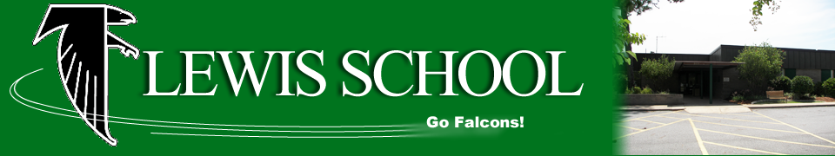

**Looking Ahead**

**Monday, Oct. 16 –** Reading Log Due

**Thursday, Oct. 19 –** Quiz: The Seminole

**Friday, Oct. 20** – Spelling Test

**Friday, Oct. 20 –** Lesson 3 Vocab Quiz (Science)

**Friday, Oct. 20 –** Quarter 1 Awards Ceremony (8:30 in the cafeteria)

|  |  |
| --- | --- |
| **Students of the Week** | |
| C:\Users\ChrPow61\AppData\Local\Microsoft\Windows\Temporary Internet Files\Content.IE5\KUNKM2MS\MC900356165[1].wmf  Mrs. Powers’  Tiger of the Week | **Idaliah** |
| Image result for owl clip art black and white  Ms. Davis’  Owl of the Week | **Lyndsy** |

***Please be sure to check our class website for updates and Homework for the week.***

lewis4thgrade.weebly.com