**Our Sixth Week in 4th Grade**

Spelling – This past week we focused on long and short /o/ sounds. Next week we will focus homophones.

Reading – Reading Reflections Logs are due Monday! Next week we will be focusing on making inferences.

Writing – We have been reviewing the basics of what makes a good paragraph, and have written the first draft of our first personal narrative – “My Best Day Ever!” Next week we will peer edit our paragraphs, and finally publish them.

Social Studies – We finished up our Florida Geography Unit this past week, and next week we will begin our unit on Flordia’s History.

Math – We have completed our chapter on Multi-digit multiplication. We will continue going back to those math facts for our next chapter on DIVISION!

Science – Another great week of science and working with different tools that scientists use. Next week we will try to finish up our unit on the Scientific Method and hopefully begin our unit on the Moon.

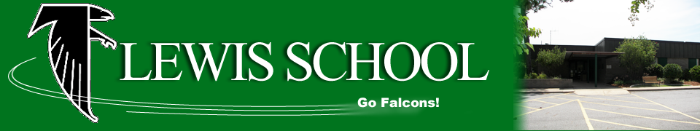

**Looking Ahead**

**Monday, Sept. 25 –** Reading Reflections Log Due

**Friday, Sept. 29 –** Spelling Test

**Friday, Sept. 29 –** Picture Order Forms Due

|  |  |
| --- | --- |
| **Students of the Week** | |
| C:\Users\ChrPow61\AppData\Local\Microsoft\Windows\Temporary Internet Files\Content.IE5\KUNKM2MS\MC900356165[1].wmf  Mrs. Powers’  Tiger of the Week | **Sawyer** |
| Image result for owl clip art black and white  Ms. Davis’  Owl of the Week | **Shai’la** |

***Please be sure to check our class website for updates and Homework for the week.***

lewis4thgrade.weebly.com

**4th Grade Classroom Wish List**

* Canon Printer Ink (#245 and #246)
* Colored Computer Paper