**Our Seventh Week in 4th Grade**

Spelling – This past week we focused on homophones. Next week we will focus on short and long /u/ vowel sounds.

Reading – Reading Reflections Logs are due Monday! Next week we will continue making inferences and talk a little about poetry

Writing – We have finished writing and publishing our first personal narrative! Next week we will begin expanding our writing by learning how to write a structurally correct multi-paragraph essay.

Social Studies – We have started talking about the Native American tribes that were in Florida many years ago.

Math – We have begun our chapter on division and will be working through it next week. Keep studying your multiplication facts!

Science – We have finished up our Unit 1 today and will be testing on it next week. We will review on Tuesday and Wednesday! Monday will be the MAP Science test. Please don't be absent.

***Please be sure to check our class website for updates and Homework for the week.***

lewis4thgrade.weebly.com

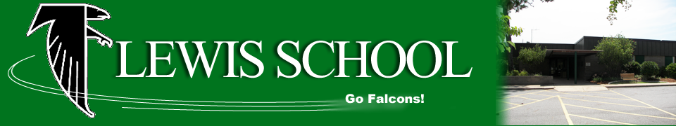

**Looking Ahead**

**Monday, Oct. 2 –** Reading Reflections Log Due

**Monday, Oct. 2** – Science MAP Test

**Wednesday, Oct. 4-** Science Unit Test

**Thursday, Oct. 5 –** Cold Read

**Friday, Oct. 6 –** Spelling Test

**Friday, Oct. 6 –** End of First Quarter

**Monday, Oct. 9 –** No School

|  |  |
| --- | --- |
| **Students of the Week** | |
| C:\Users\ChrPow61\AppData\Local\Microsoft\Windows\Temporary Internet Files\Content.IE5\KUNKM2MS\MC900356165[1].wmf  Mrs. Powers’  Tiger of the Week | **Kalib S.** |
| Image result for owl clip art black and white  Ms. Davis’  Owl of the Week | **Diana** |